Who's who in Blue this season
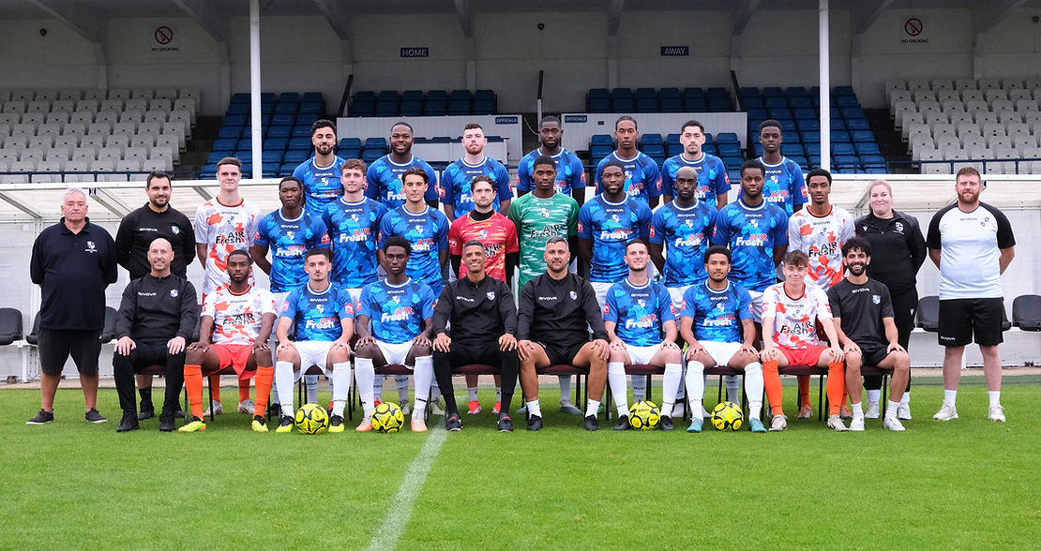
BACK ROW (L-R)

Andronicos Georgiou (Midfielder, 24 years old)
Georgiou started his career with EFL side Stevenage, making his first team debut as a teenager in 2017. From there, he had loan spells at St Albans in National League South and Hendon at step 3. After his departure from Stevenage, Wycombe Wanderers offered the Cypriot midfielder a deal as part of their B team set-up until departing in 2021. Most recently, he was playing for Royston Town during the latter stages of 2023/24.

Ogo Obi (Forward, 26)
Obi was most recently with Chesham United in 2023/24, providing numerous goals and assists as Chesham were crowned champions of Southern League Premier South. Obi was on loan from National League South side Maidstone United and has plenty of experience at step 2, with former clubs including Slough Town and Hemel Hempstead. As a teenager, Obi was on trial at Manchester United, having impressed for Watford’s academy as a youngster. Obi made his presence known on Saturday with two goals in a very lively debut performance.

Michael O'Donoghue (Defender, 28)
Michael O'Donoghue joins the Blues from last season's champions Hornchurch. O'Donoghue is a left sided defender who came through at Leyton Orient and Colchester before spending a number of years at local neighbours Haringey Borough, prior to signing for Hornchurch during 2023/24 and securing the Isthmian Premier League title there.

Khristopher Oti (Forward, 25)
Oti ended the 2023/24 season at Witham Town in the Isthmian North division where he netted 4 goals in 11 appearances. Prior to this, he had prolific spells with St Ives Town, netting double figures there after moving from Corby Town where he had 9 goals in 16 appearances. A graduate of the Colchester United academy, Oti has also achieved promotion from Isthmian South East with Whitehawk as well as playing for National League North side Brackley Town.

Luke Deslandes (Forward, 20)
Young forward Deslandes made himself known to Blues fans with a goal on debut against Concord Rangers in December 2023, having signed from Canvey Island. He continued to show flashes of his brilliance throughout his 11 appearances in the run-in last season. During pre-season this year, Deslandes has kicked on and scored numerous goals including an excellent long range effort against Watford U21s and will be looking to further demonstrate his class in 2024/25.

Brian Garzon (Midfielder, 20)
After graduating from the Southend United youth academy, including a hat-trick in the EFL Youth Cup to send his side through against Stevenage, Garzon joined Hertford Town last season and secured double digits in goals and assists as he shone for the Southern League Central (Step 4) side. Garzon signed during pre-season and scored a wonderful long range strike in a 6-1 win over Welwyn Garden City - check it out on our Instagram page!

Ferdinand Okoh (Midfielder, 20)
Ferdi has spent his early career far primarily in the academy set ups of Premier League sides, with West Ham, Tottneham and Bournemouth, appearing on the subs bench for the Cherries in 2022. He has had loan spells locally including Haringey and Hayes & Yeading, and has now signed for the Blues after leaving Bournemouth. Okoh played an influential role in helping the Cherries win their division of the EFL Youth Alliance and reach the fifth round of the FA Youth Cup in 2021-2022.

MIDDLE ROW (L-R)

Bobby Webb (Defender, 19)
Bobby Webb is another centre back retained from 2023/24. Webb was signed last season from London Colney and impressed many with maturity beyond his years, making 17 appearances in all competitions, including an excellent 90 minute performance away at champions Hornchurch.

Rhamar Garrett-Douglas (Defender, 23)
Rhamar Garrett-Douglas returns this season having made 40 appearances last season for the Blues as we made our way to the playoffs. The flying wing back started his career with Barnet youth, joining the Blues from Tilbury last summer, chipping in with goals and assists throughout the season.

Ryan Lowe (Midfielder, 20)
Ryan Lowe upon the expiry of his contract with League Two side Colchester United. Lowe captained Colchester at youth level and spent time on loan at Margate FC last season, making 5 appearances in the Isthmian Premier division. Lowe made his debut off the bench on Saturday and capped a fine performance with an all important winning goal in the 89th minute.

Arthur Iontton (Midfielder, 23)
Arthur Iontton is another exciting midfield recruit, coming from neighbouring side Haringey Borough. The 23-year old was a regular in the Haringey Borough side last season, while also counting EFL experience on his CV having come through the ranks at Stevenage and appearing 29 times in League Two as a youngster. Since then he has made a number of appearances at this level, having also played for Hendon in 2022/23.

Fergal Hale-Brown (Goalkeeper, 24)
Fergal Hale-Brown provides a known face around N12, having originally joined in the 2019/20 season. The reliable stopper joined having left the Norwich City academy and having been selected for Wales U19s as a youngster.

Prince Adegoke (Goalkeeper, 20)
Prince Adegoke made his debut on Saturday in goal, in an assured performance. Adegoke spent a number of years in Chelsea's academy, before moving to South East London to play for Charlton U21s last season. Adegoke has also spent time with Welling United on loan in National League South.

Destiny Oladipo (Forward, 22)
A tall striker, Oladipo came through the academy of Forest Green and has since spent time in National League South with Hampton & Richmond and Dover Athletic, as well as in the Isthmian Premier League with Carshalton, Cray, Hornchurch and most recently Margate where he bagged two vital goals in just five appearances in Margate's attempt to avoid the drop last season.

Toby Byron (Defender, 23)
One of the first signings made by Ahmet Rifat this summer was centre back Toby Byron. Byron joined the Blues having played for Isthmian Premier sides Hornchurch and Folkestone Invicta during 2023/24. Coming through the ranks at Luton Town's under 18s, Byron also counts local neighbours Hendon FC amongst his previous clubs.

Evangelos Epochontsif (Defender, 23)
Left-sided defender Empochontsif joined this summer, counting Canvey Island, Rushden & Diamonds and Walthamstow among his previous clubs, while also having trials with Championship side Middlesbrough as a teenager.

Loïc Hernandez (Defender, 24)
Hernandez is our most capped player in the current squad, appearing 66 times for the Blues over the past three seasons as well as a loan spell in 2018/19. Hernandez was on the books of Barnet FC throughout his youth career until signing for the Blues in 2021.

FRONT ROW (L-R)

Ayo Tanmiowo (Defender, 22)
Ayo Tanimowo joined this summer and was straight into the starting line-up on Saturday against Dulwich, providing an assist for our second goal. Ayo spent his youth career with Norwich City and Brighton and Hove Albion, playing in the U18 Premier League and Premier League 2 before joining Waltham Abbey last season, forming part of the side that reached the play-off final in the Southern League Division One Central (Step 4).

Lonit Talla (Midfielder, 22)
Talla spent the 2023/24 season with local neighbours Harrow Borough at step 3 in the Southern Premier League South, where he bagged 6 goals from midfield in 40 appearances. A graduate of the QPR academy, Talla has also spent time at Egham Town and Uxbridge. Lonit made his debut in midfield on Saturday, impressing many with his powerful performance.

Ben Frempah (Defender, 29)
Another familiar face in the backline is Ben Frempah. Frempah was a rock in defence last season, appearing in every league match after returning to the club having made a handful of appearances in 2019/20. An experienced head in this side at 29, Frempah was signed by Leicester City as a teenager and also appeared for Wycombe Wanderers.

Billy Cracknell (Defender, 22)
Billy Cracknell has been announced as this season's club captain, having made a great impression in his 31 appearances last season after joining from Bishop's Stortford. A product of Colchester's academy, Cracknell made his EFL debut in March 2021 before loan spells at Bishop's Stortford and Cheshunt, signing permanently for the former in 2023.

Zack Newton (Forward, 27)
A tenacious winger, Newton provided opposition defences with a major headache last season with his work rate and all round ability, scoring on 7 occasions in 36 appearances across the season. Prior to signing for the Blues, Newton played a vital role for Cheshunt as they achieved promotion to the National League South, scoring the vital playoff winning goal and going on to feature regularly for the Ambers in their sole National League South season.

Tommy Roberts (Midfielder, 18)
Tommy broke into the first team from our youth set-up and continued his progress last season, particularly impressing in the London Cup against Brentford B. We look forward to seeing our own "star boy" develop this season as he makes the step up from a successful season in the U18s.

